**Implementing Web Application**

|  |  |
| --- | --- |
| Date | 25 November 2022 |
| Team ID | PNT2022TMID11590 |
| Project Name | CONTAINMENT ZONE ALERTING |

**CREATE API IN FLASK :**

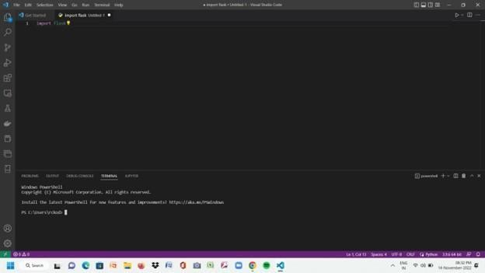

from flask import Flask app = Flask(__name__) @app.route("/") def homepage():

return "Hello Flask!" if __name__ == '__main__': app.run()

